DATA Engineering

25/06/2026
DAY 1 >> CLASS<<

SQL > STRUCTED QUERY LANGUAGE, JUST LIKE PHYTON
MY SQL> ONE OF THE DB TOOLS

WHY TO RELY ON THESE DB TOOLS?
>Excel is only local
>Excel can store only upto 10L Rows & 16384 Columns
>If You load more than 50,000 Rows, Excel will open tomorrow)
DBMS -Database management system
RDMS NRDMS
It handles only structured data It handles only unstructured data
(Rows & Columns) TOOLS ( Audio , video , text , images)

SQL WORKBENCH MANGO DB
ORACLE DB APACHE
MS SQL SERVER AMAZON
POSTGRE SQL

SQL COURSE
(BASIC TO ADVACNE )
AGENDA AT AGLANCE
1.INSTALLING MY SQL AND CREATING A DB
2.INSERTING DATA
3.DQL AND DML OPERATIONS
4.AGGREGATE FUNCTIONS & SUB QUERIES
5.JOINS AND GROUPING
6.WINDOW FUNCTIONS & STORE PROCEDURES

BEFORE WE BEGIN…
“ Small Steps each day lead
To big results tomorrow.”

26/06/2026
DAY 2 >> CLASS<<

CHAPTER1
1.INSTALLING MY SQL AND CREATING A DB (DATABASE)

CREATE NEW TABLE & ROWS

STUDENTS
STUDENT ID | FIRST NAME | LAST NAME | BIRTHDATE | GENDER
1 | JOHN | DOE | 2000-05-15 | MALE
2 | JANE | SMITH | 2000-04-20 | FEMALE
3 | MANI | KANDAN | 2000-02-14 | MALE

COURSES
COURSE ID | COURSE NAME | CREDITS
1 | MATHS | 3
2 | SCIENCE | 4
3 | SOCIAL | 2

ENROLLMENT
ENROLLMENT ID | STUDENT ID | COURSE ID | ENROLLMENT DATE
1 | 1 | 1 | 2021-1-21
2 | 2 | 2 | 2000-1-10
3 | 2 | 3 | 1999-10-27

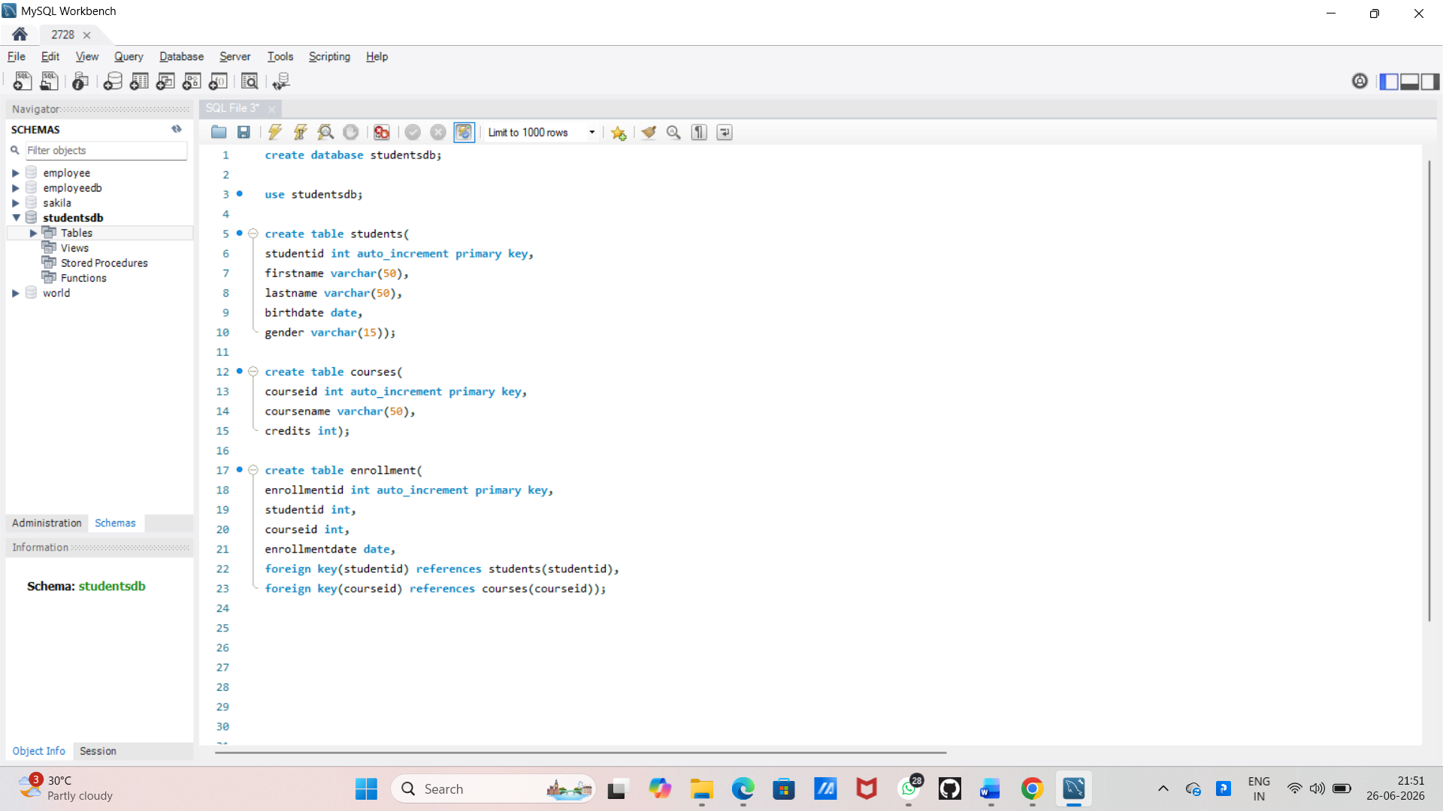

IMPORT TERMINOLOGIES
PRIMARY KEY : A unique identifier for each row in a table, ensuring that each row is distinct.
FOREIGN KEY: A column or set of columns in one table that refers to the primary key in another table , establishing a relationship between the two tables.

27/06/2026
DAY 3 >> CLASS<<
GLANCE
HOW TO APPLY
ADD
RENAME
DROP

FOR EXAMPLE:

HOW TO STUDENT TABLE ADD COLUMN
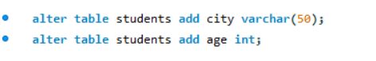
HOW TO STUDENT TABLE RENAME COLUMN

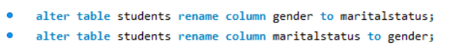
HOW TO STUDENT TABLE DROP COLUMN
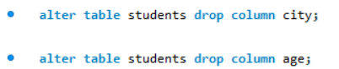

CHAPTER 2
2. INSERTING DATA & SELECTING DATA

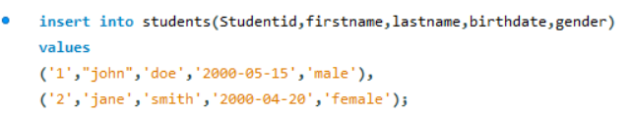

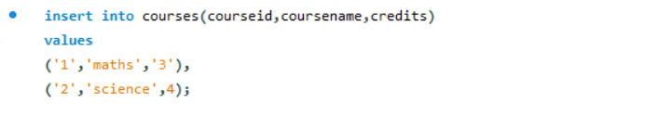
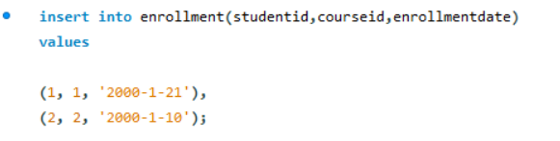

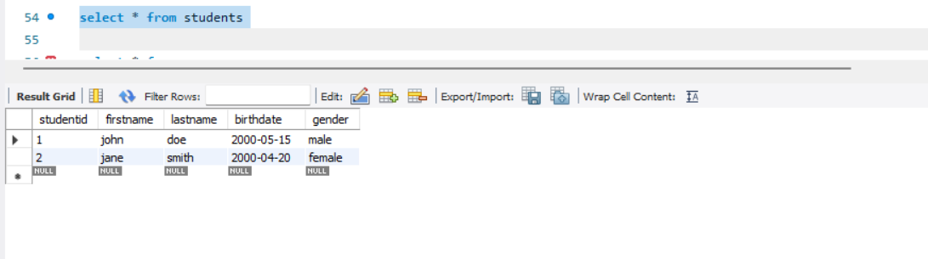

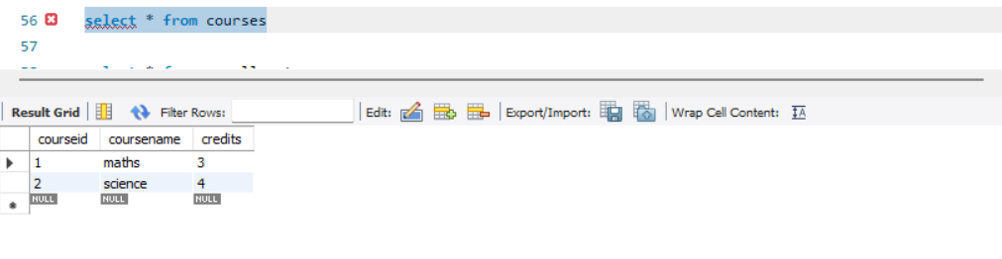
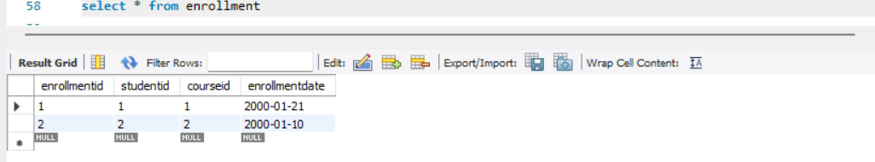

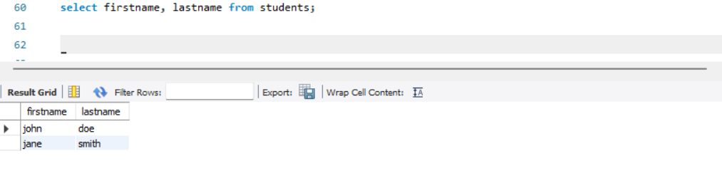

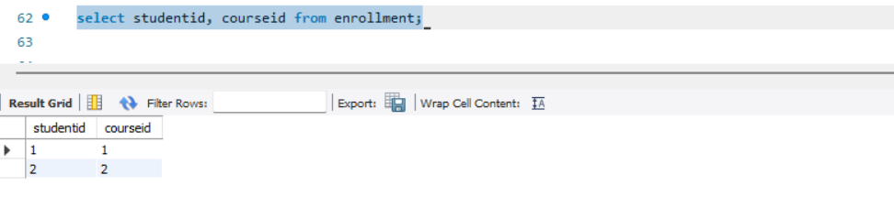

28/06/2026
DAY 4 >> CLASS<<
GLANCE

4 MAIN CATEGORIES OF SQL STATEMENS
Data definition language (DDL)
Data management language (DML)
Data control language (DCL)
Data query language (DQL)

Data definition language (DDL)
CREATE : USED TO CREATE NEW DATA BASE OBJECTS,,SUCH AS TABLES, INDEXES, NAD VIEWS.
ALTER : USED TO MODIFY THE STRUCTURE OF EXISTING DATABASE OBJECTS.

FOR EXAMPLE
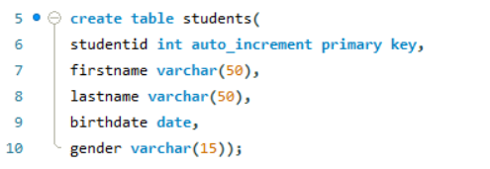

Data Manipulation language (DML)
INSERT ; ADDS NEW RECORDS TO A TABLE
UPDATE : MODIFIES EXISTING RECORDS IN A TABLE.

FOR EXAMPLE
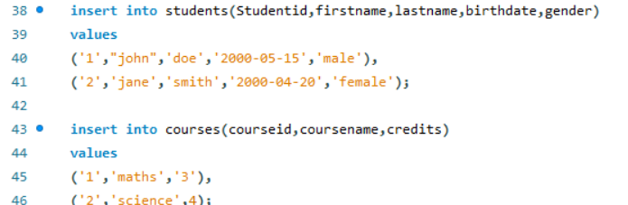

Data control language (DCL)
GRANT : PROVIDES SPECIFIC PRIVILEGES TO USER OR ROLES.
REVOKE: REMOVES SPECIFIC PRIVILEGES FROM USER OR ROLES.

Data query language (DQL)
SELECT : RETRIEVES DATA FROM ONE OR MORE TABLES BASED ON SPECIFIED CRITERIA.

FOR EXAMPLE :
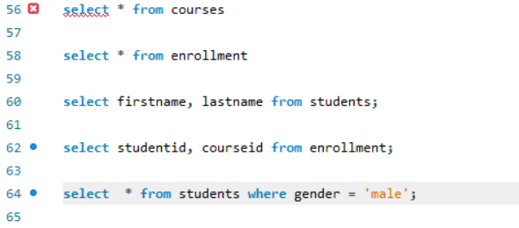

SEQUENCE OF EXECUTION ( FIRST WE GET HUNGRY SO ORDER LUNCH)
RUNS TO SQL STEP

STEP | CLAUSE | PURPOSE
1 | FROM | SPECFIES THE DATA SOURC ( TABLES,VIEWS,JOINGS)
2 | WHERE | ROW BASED ON SPECIFIED CONDITION
3 | GROUPBY | GROUPS ROWS INTO SUBSET ON ONE OR MORE COLUMNS FOR AGGREGATION
4 | HAVING | FILTER GROUP CREATED BY GROUPBY BASED ON CONDITION
5 | SELECT | SPECIFIC COLUMNS , CALCULATED EXPRESSION, OR AGGREGATED VALUES FOR THE OUTPUT.
6 | ORDERBY | SPECIFIED COLUMNS IN ASCENDING(ASC)OR DESCENDING (DESC) ORDER.
7 | LIMIT | RESTRICTS THE NUMBER OF ROWS – RETURNED IN THE RESULT SET.

DQL ASSIGNMENT
create database employee_db;

use employee_db;

create table employee(
emp_id int primary key,
emp_name varchar(50),
gender varchar(50),
department varchar(50),
salary decimal(10,2),
hiredate date,
city varchar(50));

insert into employee values
(101, 'john', 'male', 'it', 65000, '2021-01-15', 'chennai'),
(102, 'sarah', 'female','hr', 45000, '2020-04-15', 'bangalore'),
(103, 'david', 'male', 'finance', 70000,'2018-05-08', 'mumbai'),
(104, 'priya', 'female', 'it', 80000, '2022-05-07', 'chennai'),
(105, 'ahmed', 'male', 'sales', 55000, '2015-05-07', 'hyderbad'),
(106, 'meena', 'female', 'hr', 50000, '2000-07-07', 'delhi'),
(107, 'raj', 'male', 'it',90000, '2000-08-08', 'bangalore'),
(108, 'anitha', 'female', 'finance', 75000, '2000-04-04', 'chennai'),
(109, 'kumar', 'male', 'sales', 60000, '2000-02-02', 'mumbai'),
(110, 'fatima', 'femnale', 'it', 85000, '2000-07-02', 'hyderabad');

NO:1
DISPLAY ALL EMPLOYEES
KEY
select * from employee

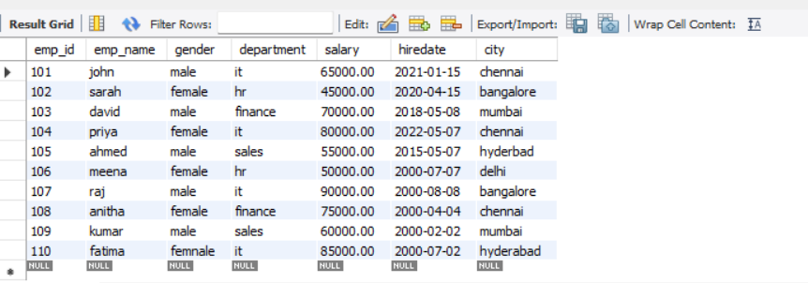

NO.2
DISPLAY EMPLOYEE NAMES AND SALARIES.
SELECT EMP_NAME,SALARY FROM EMPLOYEE;

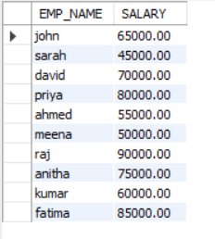

NO.3
SHOW EMPLOYEES WORKINGS ON IT
SELECT * FROM EMPLOYEE WHERE DEPARTMENT = 'IT';

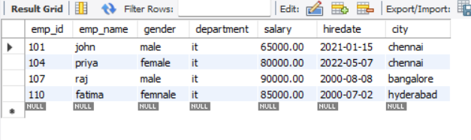

NO.4
SHOW ENPLOYEES EARNING MORE THAN 60000
SELECT * FROM EMPLOYEE WHERE SALARY > 60000;

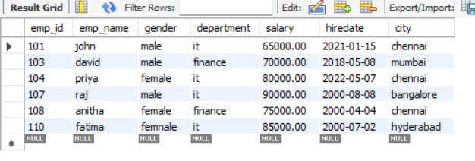

NO.5
DISPLAY EMPLOYEES FROM CHENNAI
SELECT * FROM EMPLOYEE WHERE CITY = 'CHENNAI';

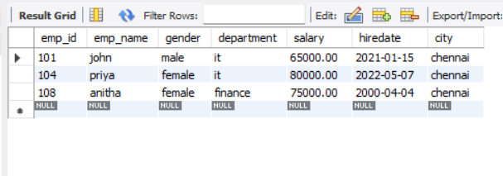
NO.6
FIND EMPLOYEE HIRED AFTER 2021
SELECT * FROM EMPLOYEE WHERE HIREDATE > '2021-12-31';
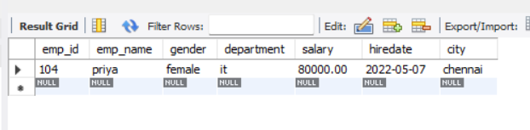

NO.7
DISPLAY EMPLOYEE SORTED BY SALARY
SELECT * FROM EMPLOYEE ORDER BY SALARY ASC;

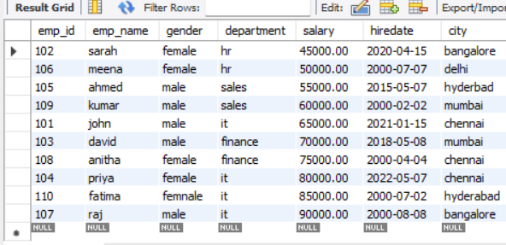

NO.8,
FIND THE HIGHEST PAID EMPLOYEE.
SELECT * FROM EMPLOYEE ORDER BY SALARY DESC LIMIT 1;
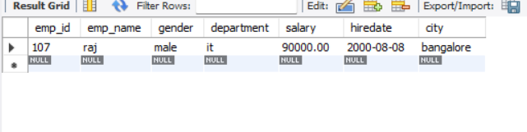
N0.9
FIND THE AVERAGE SALARY
SELECT AVG(SALARY) AS Average_Salary FROM EMPLOYEE;

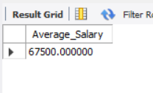

NO.10
COUNT THE EMPLOYEE IN EACH DEPARTMENT
SELECT DEPARTMENT, COUNT(*) AS Total_Employees FROM EMPLOYEE GROUP BY DEPARTMENT;
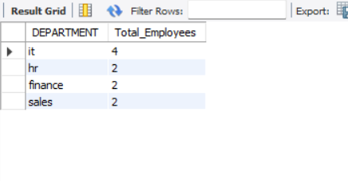
NO.11
DISPLAY DEPARTMENT HAVING MORE THAN 2 EMPLOYEE
SELECT DEPARTMENT, COUNT(*) AS Total_Employees FROM EMPLOYEE GROUP BY DEPARTMENT HAVING COUNT(*) > 2;
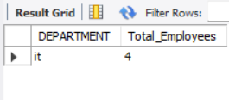
NO.12
DISPLAY UINIQUE CITIES
SELECT DISTINCT CITY FROM EMPLOYEE;
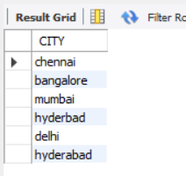

NO .13
SHOWS EMPLOYEES WHOSE NAME START WITH ‘a’
SELECT * FROM EMPLOYEE WHERE EMP_NAME LIKE 'A%';
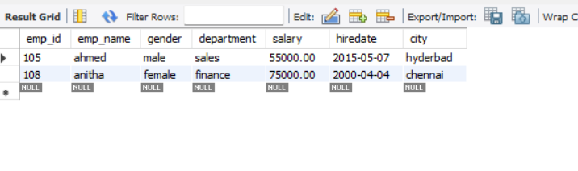

NO.14
SHOW EMPLOYEE WITH SALARY BETWEEN 50000 TO 80000
SELECT * FROM EMPLOYEE WHERE SALARY BETWEEN 50000 AND 80000;

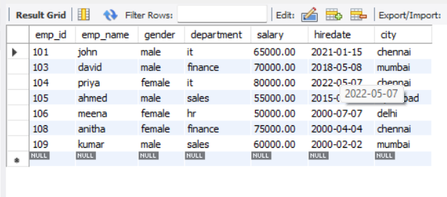
NO.15
DISPLAY THE TOP THREE HIGHEST PAID EMPLOYEES
SELECT * FROM EMPLOYEE ORDER BY SALARY DESC LIMIT 3;
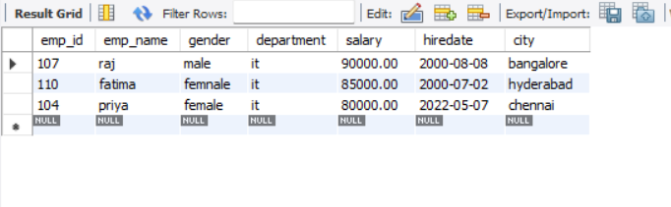

THEORY

- What does TCL stand for?
TCL (Transaction Control Language) is a category of SQL commands used to manage database transactions using commands such as COMMIT, ROLLBACK, and SAVEPOINT.

- Name the TCL commands?

The TCL commands are COMMIT, ROLLBACK, SAVEPOINT, ROLLBACK TO SAVEPOINT, and SET
TRANSACTION. They are used to control and manage database transactions.

- What is the purpose of COMMIT?
COMMIT is a TCL command that permanently saves all changes made during the current transaction to the database.
- What is the difference between COMMIT and ROLLBACK?
COMMIT permanently saves the changes made in a transaction, whereas ROLLBACK cancels the uncommitted changes and restores the database to its previous state.
- What does SAVEPOINT do?
SAVEPOINT creates a checkpoint in a transaction so you can roll back to that point without undoing the entire transaction.
- What does DCL stand for?

DCL (Data Control Language) is a category of SQL commands used to control user access and permissions in a database using GRANT and REVOKE.
- Name the DCL commands?

The DCL commands are GRANT and REVOKE, which are used to grant and remove user permissions in a database.
GRANT SELECT, INSERT
ON employee TO user1;
REVOKE INSERT
ON employee FROM user1;

- What is the purpose of GRANT?

GRANT is a DCL command used to give users or roles specific permissions on database objects
- What is the purpose of REVOKE?

REVOKE is a DCL command used to remove previously granted permissions or privileges from a user or role.

- Can we rollback after COMMIT? Explain ?

No. After a COMMIT, the changes are permanently saved, so they cannot be undone using ROLLBACK.

SETUP
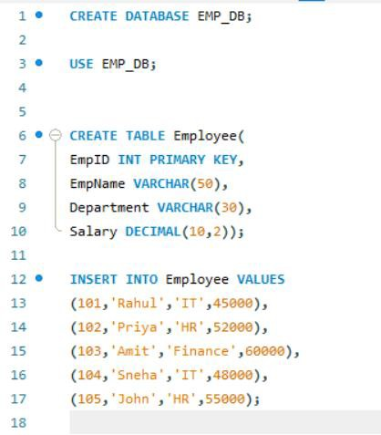

Increase Rahul's salary by ₹5000. Do not commit immediately. Verify the result. Rollback the transaction. What is Rahul's final salary?
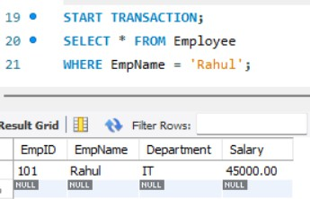

Increase every employee's salary by 10%. Commit the transaction. Verify the result.
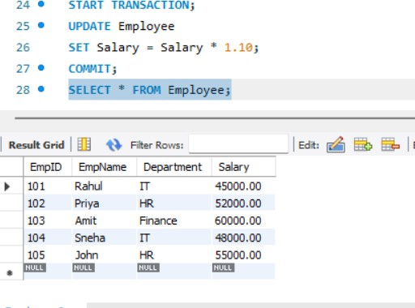

Increase Rahul's salary by ₹3000. Create SAVEPOINT sp1. Increase Priya's salary by ₹5000. Rollback to sp1. Which employee's salary is rolled back?

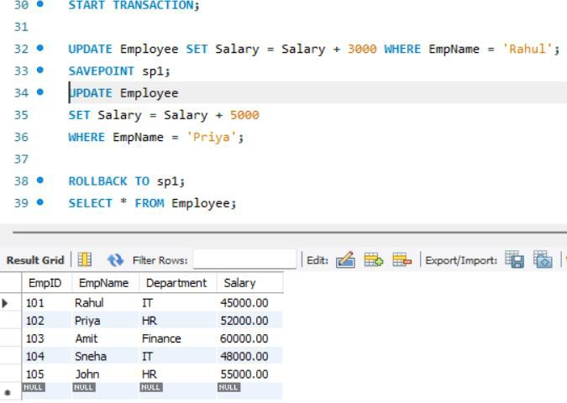

DELETE HR employees. Rollback. How many HR employees remain?
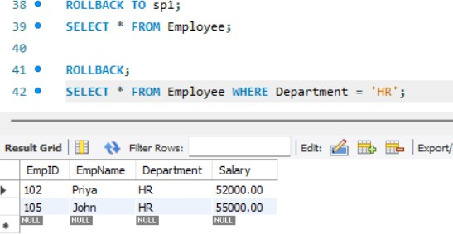

DELETE Finance employees. COMMIT. Then ROLLBACK. Will the Finance employee return? Explain
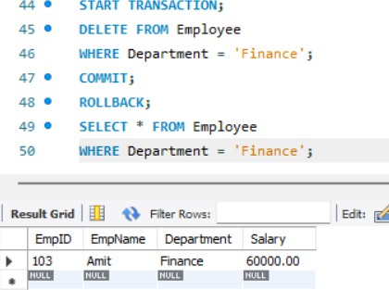

DCL

Write a query to GRANT SELECT on Employee to student1.
GRANT SELECT ON Employee TO student1;

Write a query to GRANT INSERT on Employee to student1.
GRANT INSERT ON Employee TO student1;

Write a query to GRANT UPDATE on Employee to student1.
GRANT UPDATE ON Employee TO student1;

Write a query to REVOKE INSERT from student1
REVOKE INSERT ON Employee FROM student1;

Write a query to REVOKE ALL permissions from student1
REVOKE ALL PRIVILEGES ON Employee FROM student1;

Scenario Based
A cashier accidentally updates 500 customer records before commit. Which TCL command should be used?
START TRANSACTION;

UPDATE Customer
SET Balance = Balance + 1000;

-- Mistake detected

ROLLBACK;

Salary changes are verified and should become permanent. Which command should be used?

START TRANSACTION;

UPDATE Employee
SET Salary = Salary + 5000 WHERE Department = 'IT';

COMMIT;

Undo only the last set of changes without affecting earlier updates. Which command should be used?
START TRANSACTION;
UPDATE Employee
SET Salary = Salary + 3000 WHERE EmpID = 101; SAVEPOINT sp1;

UPDATE Employee
SET Salary = Salary + 5000 WHERE EmpID = 102;

ROLLBACK TO sp1;

A new employee should only view employee records. Which DCL command will you use?

GRANT SELECT
ON Employee
TO new_employee;

A user should no longer have permission to delete records. Which DCL command will you use?
REVOKE DELETE ON Employee FROM user1;

Output Prediction

START TRANSACTION;
UPDATE Employee SET Salary=Salary+5000 WHERE EmpID=101; ROLLBACK;
SELECT Salary FROM Employee WHERE EmpID=101;

Will the updated or original salary be displayed?

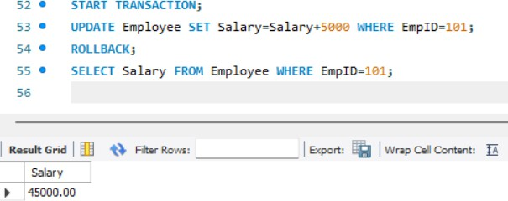

START TRANSACTION;
UPDATE Employee SET Salary=Salary+5000 WHERE EmpID=101; COMMIT; ROLLBACK;

Is the salary restored? Why?
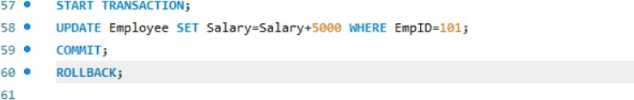

No. After COMMIT, the salary change is permanently saved, so ROLLBACK cannot restore the original salary.

Which employee receives the salary increment?
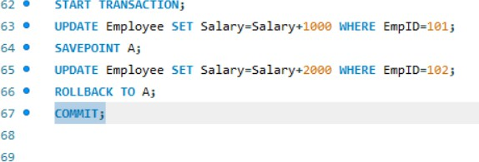

Only Employee 101 receives the salary increment because ROLLBACK TO A undoes the changes made after the savepoint, and COMMIT saves the remaining changes.

Final questions

Increase all IT salaries by 15%
UPDATE Employee – Updates the Employee table.
SET Salary = Salary * 1.15 – Increases the salary by 15%.
WHERE Department = 'IT' – Applies the increase only to employees in the IT department.

Create a SAVEPOINT.
SAVEPOINT sp1;

Increase all HR salaries by ₹2,000.
UPDATE Employee – Updates the Employee table.
SET Salary = Salary + 2000 – Increases the salary by ₹2,000.
WHERE Department = 'HR' – Applies the increase only to employees in the HR department.

Rollback only the HR update.
ROLLBACK TO sp1;

Commit remaining changes.
Use the COMMIT command to permanently save the remaining changes after rolling back the HR update.

Grant SELECT and UPDATE to student1.
GRANT SELECT, UPDATE ON Employee TO student1;

Revoke only UPDATE from student1.
REVOKE UPDATE ON Employee FROM student1;

02-07-2026
WHERE
Common Uses of WHERE
WITH EXAMPLE
